TI 22 – 55. Technology Example – Aptera CoMic Micelle Analysis system

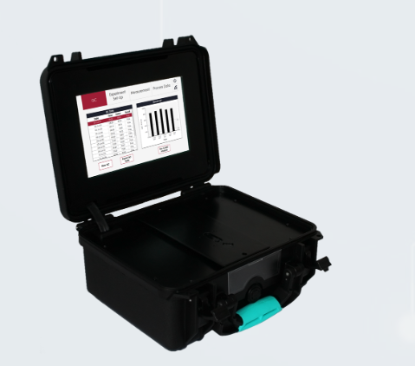
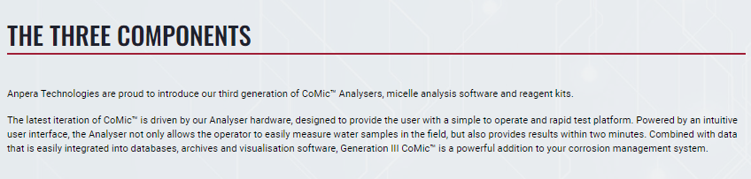
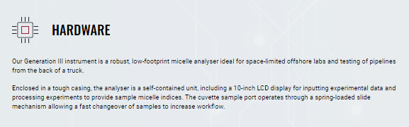
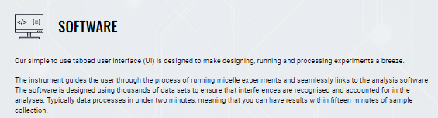

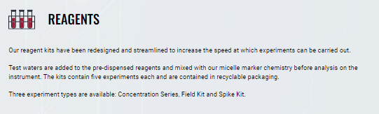
This is an extract from the vendors webpage and is an example of Field analysis kits for further information see the full website using the link below
Link: CoMic Platform | Anpera Technolgies

